Software design and development year 12
Assessment task 2
Noah Hallows

Identification of the problem:
In the modern world there are a significant number of photos taken by people all the time. This poses significant privacy and possible safety concerns as anyone will be able to access information about your appearance, location history and friends or someone could use these pictures to make sexually explicit content of you using AI. However, searching through large numbers of photos to remove your face is not a viable solution. My solution is an automated system that uses open-source face recognition to search through large numbers of images and then deletes or edits the images with the users face to anonymize them.
Generation of ideas:
I have always been concerned with my digital privacy and since I have stopped being home schooled, I have had significantly more photos of me taken by other people. I found inspiration for my system when I was watching a Japanese cyberpunk anime one of the characters would hack computer systems to place a logo over their face to preserve their anonymity, which gave me the idea to do a similar thing with python.

Requirements of the solution
- Accurately identify faces of any demographic
- Accurately blur/remove these faces without destroying the whole image
- Only run on the specified images
- Have a low difficulty bar to use
- Run quickly on small numbers of images

Communication with others:
- Ana Williams (teacher)
- Brendon Godfrey
- Zeek Mattaronno
- John Hallows (father)
- Chris Web
Selection of appropriate data types and data structure:
This software solution will use two main data types, strings to store the location of images and numpy arrays to store the processed images.
- Image containing face to search for – ARRAY
- Images to search – ARRAYS
- Location of image containing face to search for – STRING
- Location of images to search – String

Draft interface design: I used html, css and javascript to make a mockup interface design the screenshot doesn’t display the whole design.

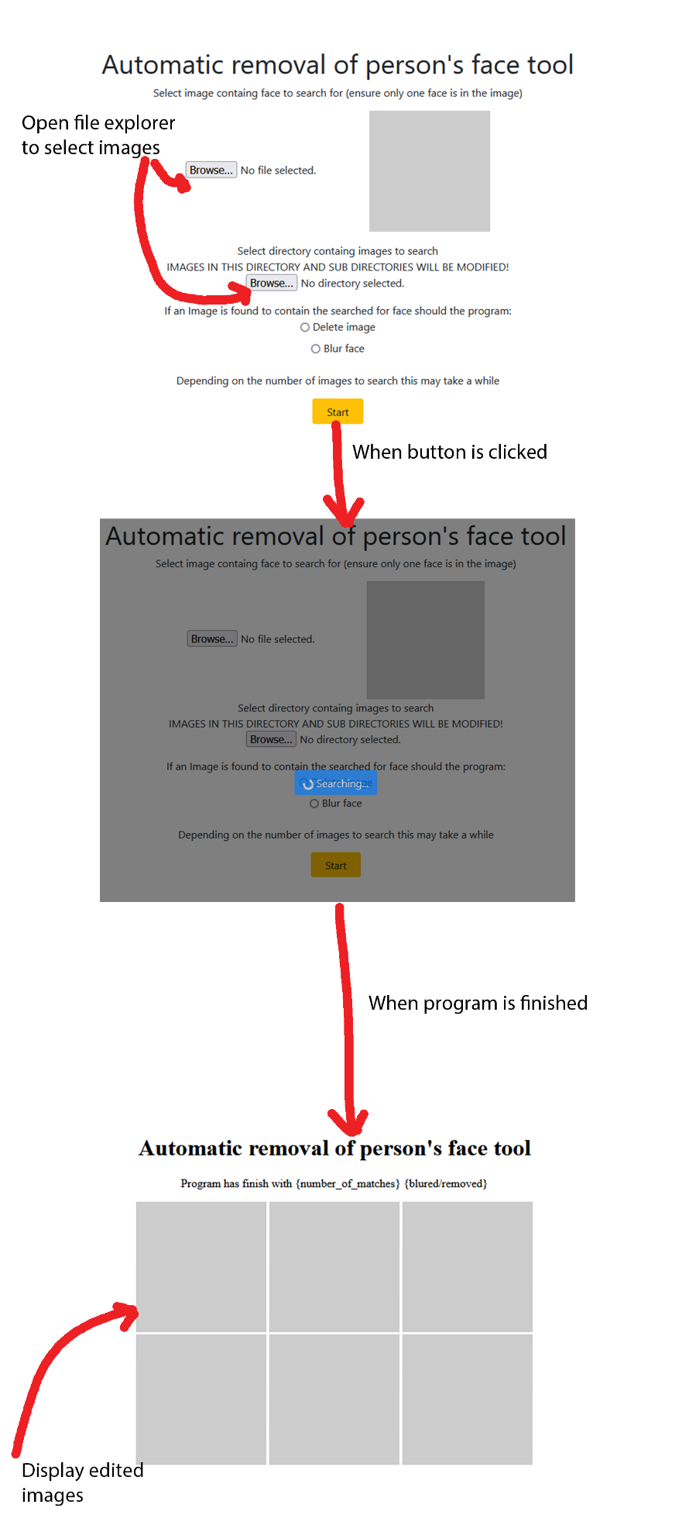

Social and Ethical issues:
Face recognition is the topic of significant debate about its potential for misuse. As with most projects containing face recognition my project has the potential for abuse however I have taken steps to minimize this through only identifying the face of the individual searched for, meaning this can't be used for surveillance, and using open-source software to ensure non authorized people aren’t using my project for nefarious purposes. Additionally, there have been issues with face recognition software not recognizing people who are of different demographics to the developers, I will run extensive testing to reduce these issues as much as possible in my software. This program could accidentally remove the wrong person from pictures which could cause harm, this could be mitigated by adding a manual confirmation system to the program. I am also only using open-source software in accordance with its licensing.

IPO diagram
Input | Processing | Output
Image of person to find | Run face recognition on image
Blur or delete images containing face searched for
Location of images to search | If image contains the person the program is looking for edit the image according to the previous input | Edited images

Context diagram

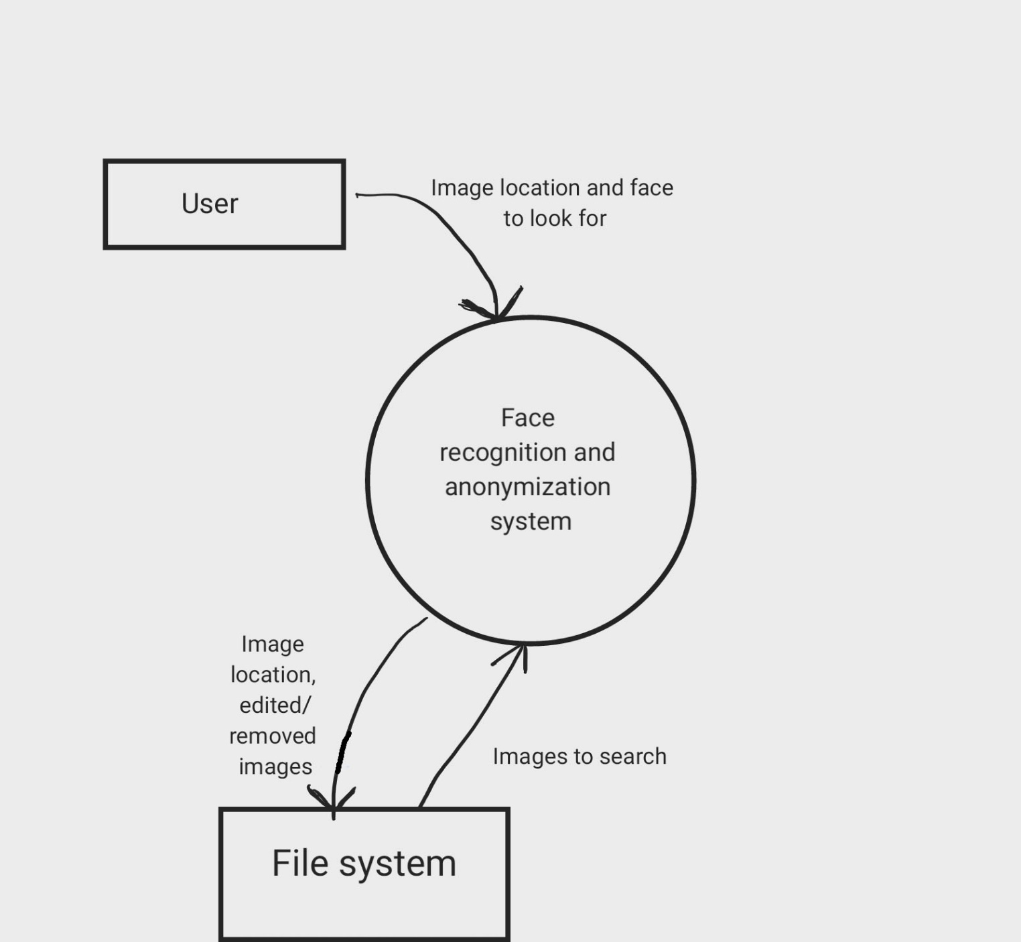

Data flow diagram

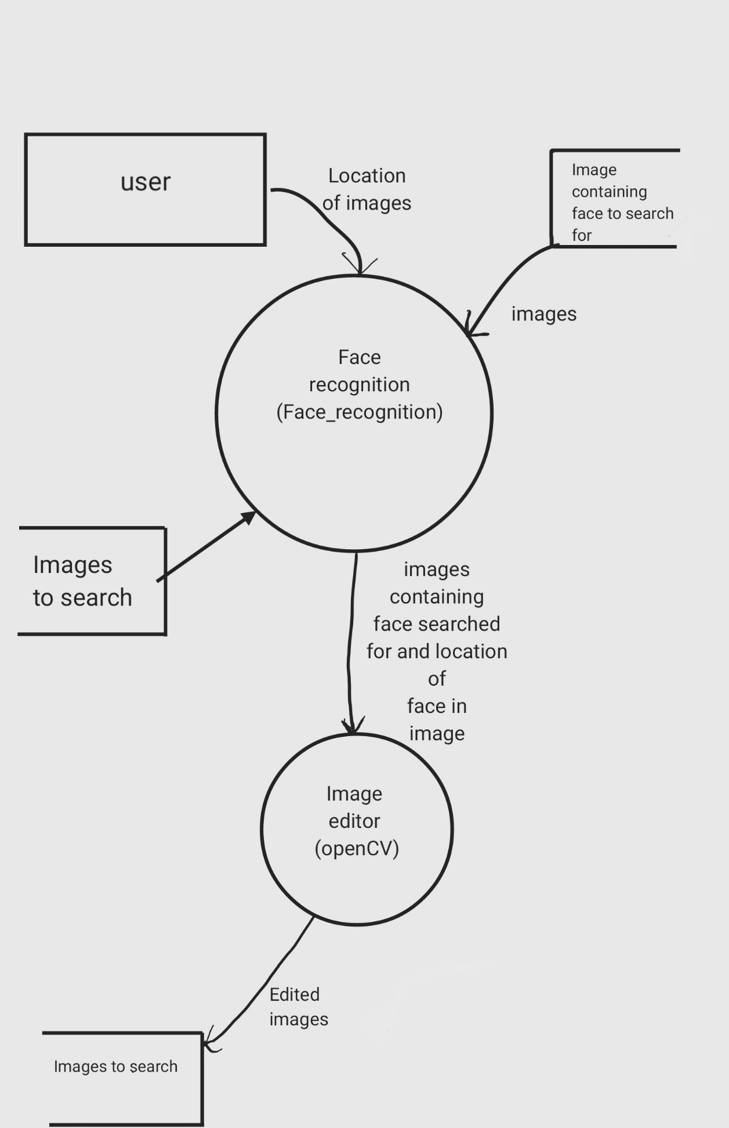

Structure chart

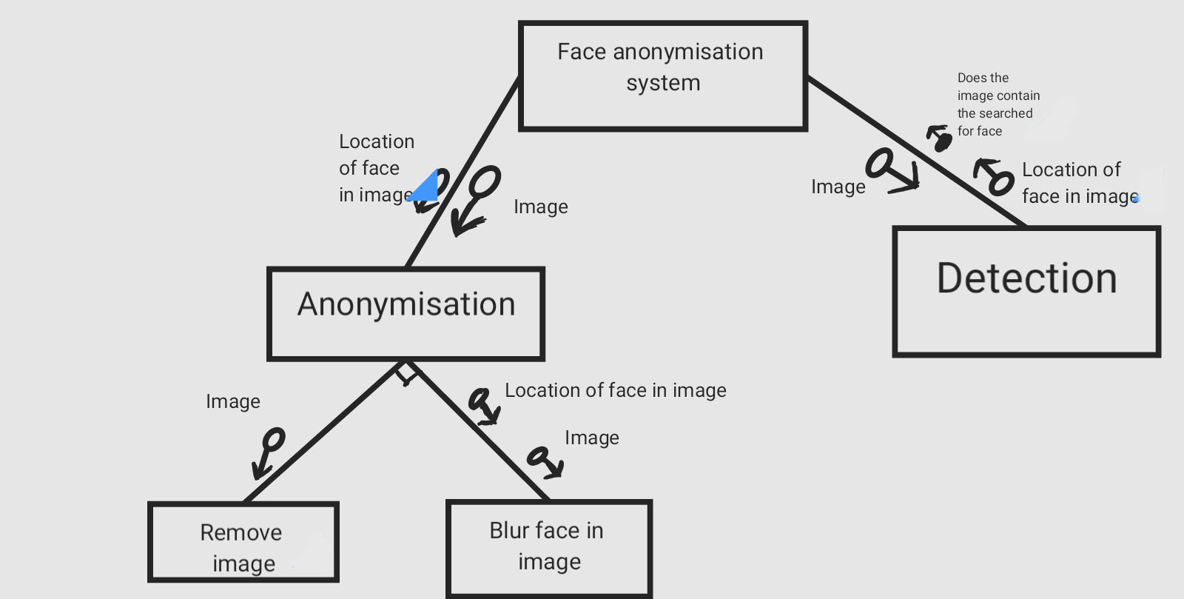

System flow chart

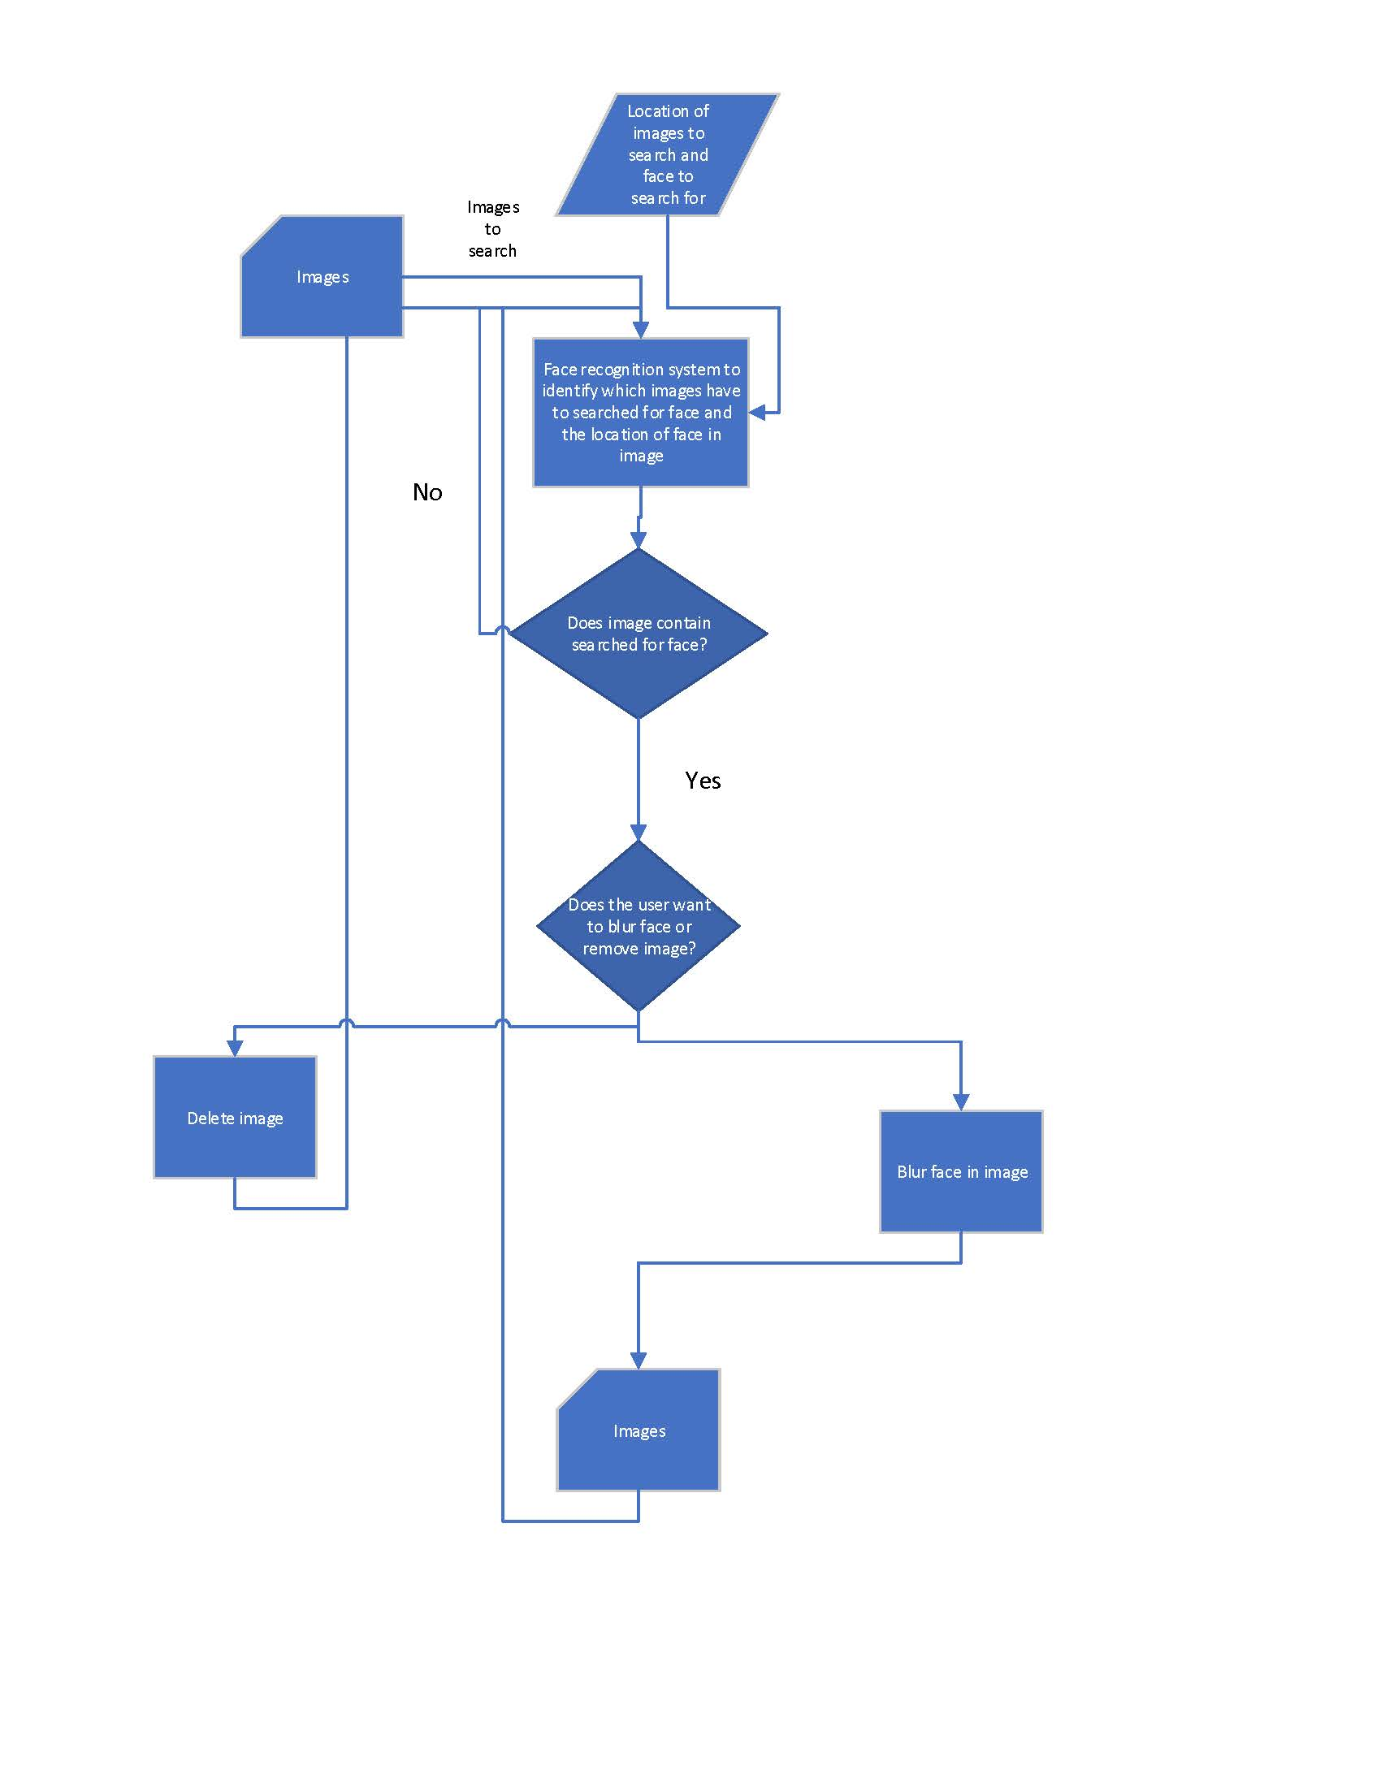

Data Dictionary

item | Data type | Description | validation
face_to_search_for | string | String that stores the location of the image containing the face to search for | File exists, valid file directory format
images_to_search | string | String that stores the directory of images to search | Directory exists, valid file directory format
face_to_search_for | Image(eg .png) | Image containing face to search for | Checks the face contains an image, checks it’s a valid image file
Image_to_search | Image(eg .png) | Image to search | Check it’s a valid image file
edited_image | Image(eg .png) | Edited version of “image_to_search” to remove face searched for | Check it’s a valid image file
blur | boolean | True/false value to specify if the program should delete the image or blur the face | NA

Planning and designing

Algorithm

Pseudocode

Frontend:

BEGIN Automatic_removal_of_face_frontend

DISPLAY("Select the image containing the face to search for: ")
face_to_search_for_location <- INPUT()
DISPLAY("Select the directory containing the images to search: ")
images_to_search_location <- INPUT()
DISPLAY(“What sould the program do to matching faces: “)
action <- INPUT.RADIOBUTTON{
"Blur matching faces"
"Replace matching faces"
"Delete images containg matching faces"
}
DISPLAY(“Finished”)

END Automatic_removal_of_face_frontend

Algorithm flow chart

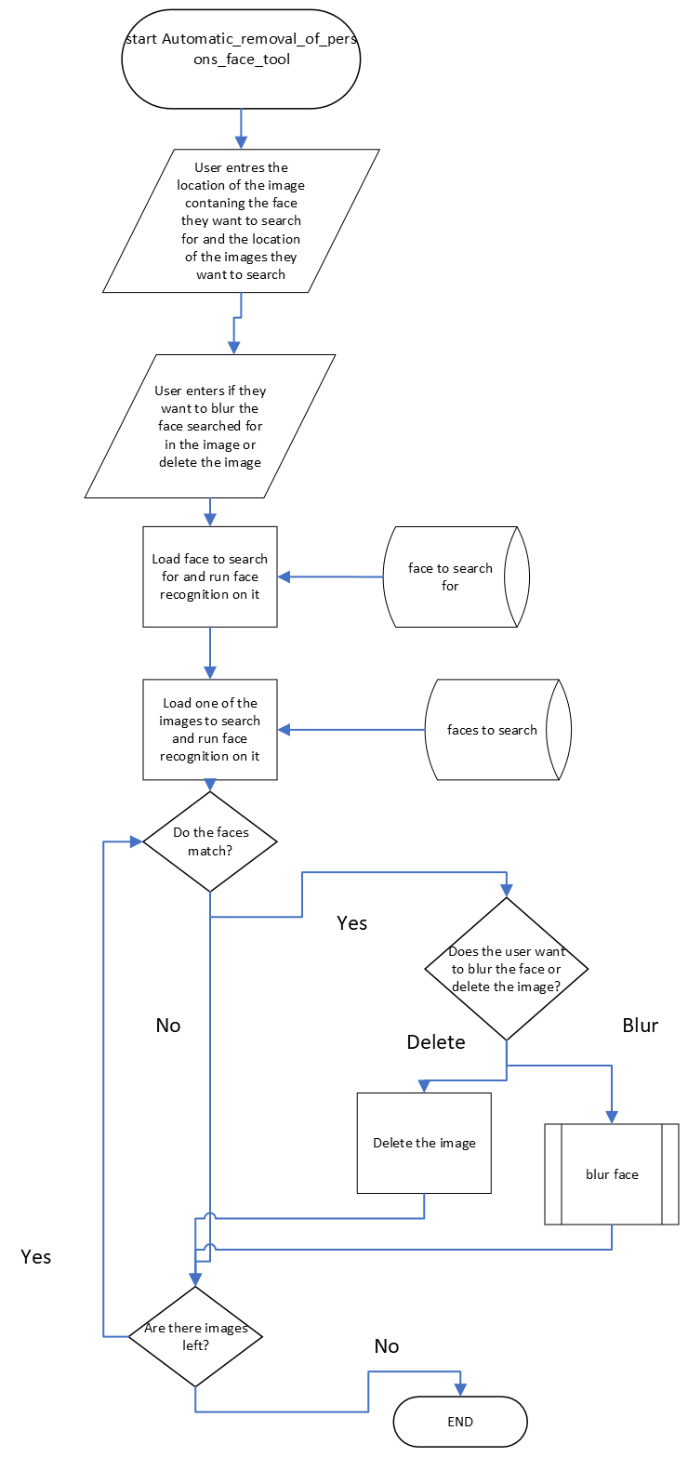
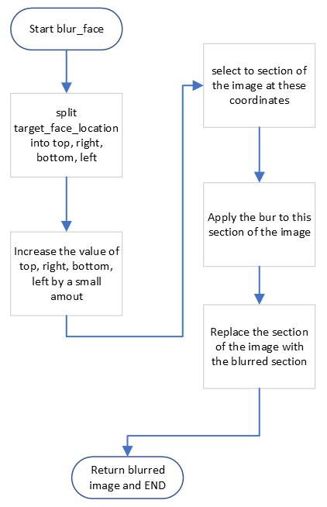
Refined system modeling tools

Data Dictionary
item | Data type | Description | validation
face_to_search_for_location | string | String that stores the location of the image containing the face to search for | File exist, valid file directory format
images_to_search_location | string | String that stores the directory of images to search | Directory exist, valid file directory format
n | int | Int to keep track of what image is being used | NA
face_to_search_for | numpy array | Face to search for loaded into face_recognition | NA
image | numpy array | Image to be search loaded into face_recognition | NA
face_to_search_for_encoding | numpy array | Variable to store the processed face to search for | NA
image_encoding | numpy array | Variable to store the processed image to search | NA
blur | Boolean | True/false value to specify if the program should delete the image or blur the face | Checks it is a valid Boolean

System Flow chart

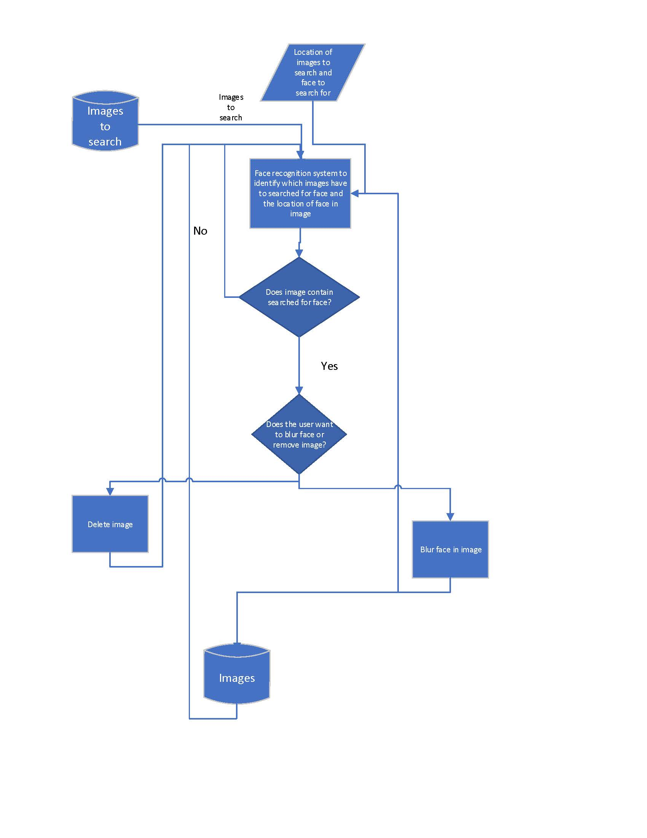

Software environment

As this program will be doing advanced AI processing and image manipulation this makes many lower-level languages such as C or COBOL unsuited for this purpose. Out of high-level languages the best suited in my opinion is Python as it has support for packages and is the most popular for machine learning, allowing me to utilize per-existing packages to reduce the need for me to write extremely complex code. Python also has other benefits such as being an interpretation language, so I don’t need to compile code when I am writing and debugging my software solution and its cross-platform support. The next best language for this project is C# because like python it is a high-level language that has machine learning capabilities; however, I didn’t choose it because it doesn’t have as good cross platform support which would make development much harder for me as a will be writing this software on a Linux machine and it would likely be run on Windows computers. Additionally, because it was created by Microsoft, I expect I’ll have issues getting it to work on Linux.

Hardware requirements

This software will run on most x86_64 computers from the last 15 years. However, it may not run quickly. I would recommend using at least a quad core 3rd gen intel core series or newer to get decent performance. A GPU is not required, however running the face recognition on a GPU will make it quicker. For GPU acceleration, a Nvidia GPU with CUDA is required.

Data files

This program will need the .py file to run or an equivalent file containing the software’s code. The only other files needed are the image file the user input into the program. Additionally, as my solution uses existing libraries the files containing these libraries are also required.

Data structure

My solution will access the images from the file system. It will load these images into numpy arrays to allow the program to process them. Then once the processing is done, faces detected and blurred, the arrays are converted back to images and written to the file system in place of the original images.
There are also some other variables that the program uses to store options, for example a Boolean to store if the program should blur the face searched for or remove the image and a string containing the location of the images.

Identifying Relevant Standard or Common Modules or Subroutines

This program is already reasonable modular due to the use of per-existing libraries, however the code to blur or remove the image could be split off to allow easier addition of different actions the program could take such as placing a new image over the identified face.

Social and ethical issues & Communication with others

In order to keep this document as ordered and logical as possible I have integrated these sections with the previous section on social and ethical issues and communication with others respectively.

User feedback
Depending on the final form of the software, it may be a web app or run locally, different systems will have to be in place to interoperate user feedback and updates. For both there will be links to a website and an email address likely at the bottom of the screen for the user to provide feedback via. If it is locally run there will have to be an additional module to check for and download updates if available to implement any changes suggested.

Documentation of design

I will be using Libre Office writer to maintain a logbook of my work and Libre Office cal (excel alternative) to manage a Gannt chart to plan my time. I will additionally be using GitHub for management of files and version control. My GitHub repository is at https://github.com/NoahHallows/software_mp This is in addition to updating parts of this document such as the data dictionary as required.

Implementing:

Issues with initial design:

When attempting to implement my original design I encountered several issues with the first being the slow speed of the solution. By far the slowest part of my code was the actual face recognition which was run on the image as a whole and then the individual faces to identify the location of the matching face. This was a difficult issue to address as I didn’t possess the time and knowledge to rewrite the face recognition library I was using, leaving me with two options. I could switch to a different, hopefully faster, library however, this had no guarantee to actually improve performance and would require rewriting a significant portion of my code, or I could use multiple cpu cores, running the processing in parallel. I ultimately decided to implement multithreading which has to bonus of fixing my next major issue, however I may switch to a different more modern face recognition library in the future. My next major issue is implementing a progress bar for my solution. On the surface this seems to be a simple task, have a variable tracking the number of images processed and use that to work out a percentage which you display to the user. However this simple approach requires the program to run asynchronously with a frontend and backend thread. Unfortunately the framework I originally intended to use, PySimpleGUI, was giving an error related to X11 when I tried to implement this feature so I decided to switch to PySide6 instead. One advantage of this multithreaded approach is the user is still able to interact with the ui while the program is running the image processing.

Changes to design and updated documentation:

I had to split the program into several sub-programs to implement the multithreading. This had the bonus of making the program more modular.

Algorithm flow charts: Frontend
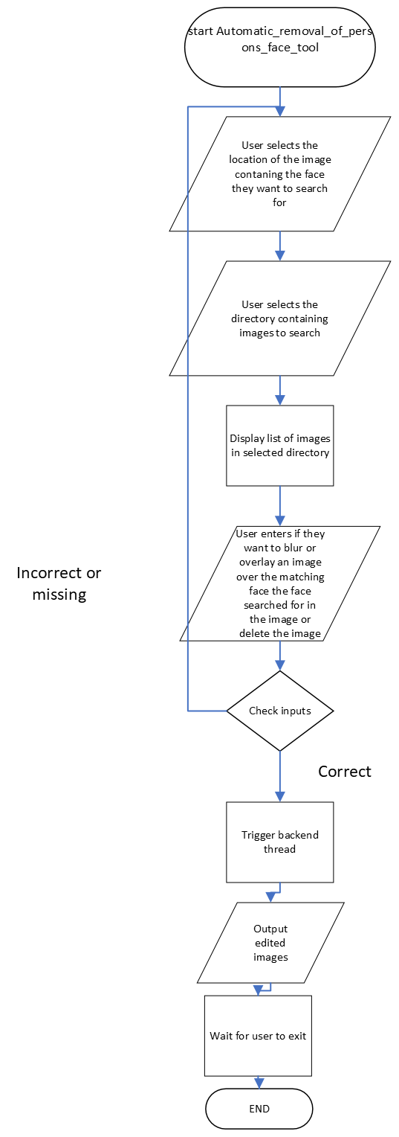
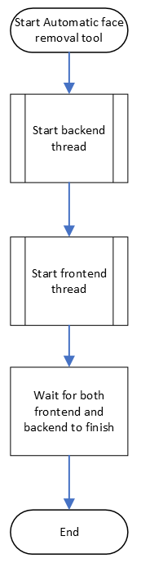
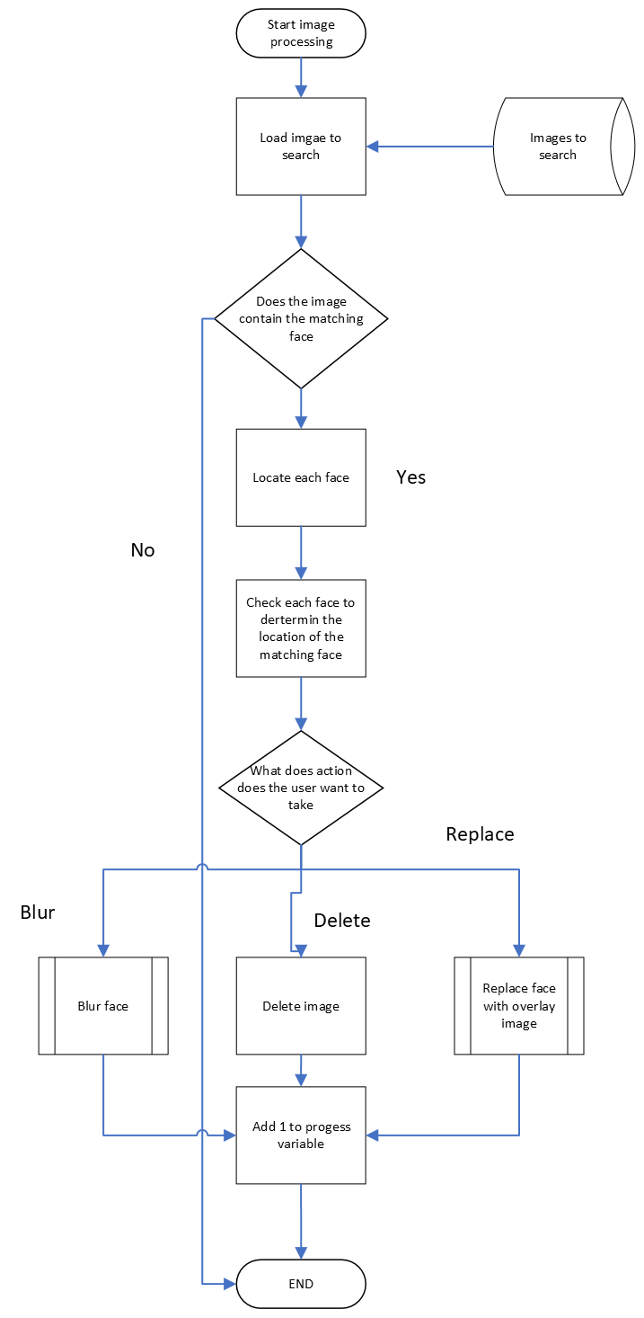
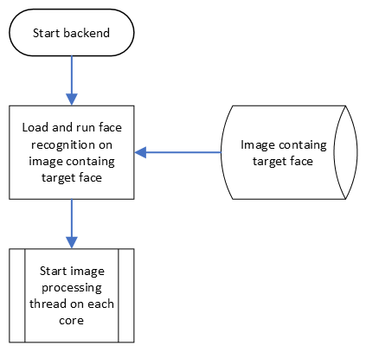
Backend:

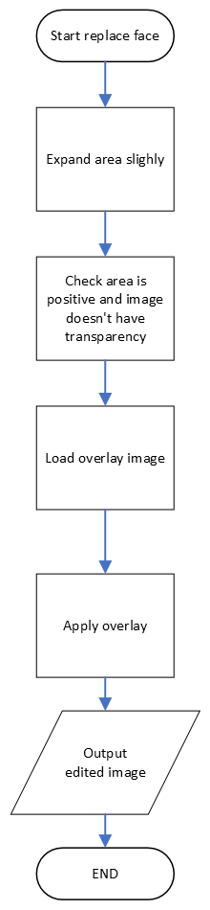

Data dictionary:

item | Data type | Description | validation
face_to_search_for | string | String that stores the location of the image containing the face to search for | File exists, valid file directory format
images_to_search_location | string | String that stores the directory of images to search | Directory exists, valid file directory format
face_to_search_for | Image array(eg .png) | Image containing face to search for | Checks the face contains an image, checks it’s a valid image file
Image_name | Image array(eg .png) | Image to currently check | Check it’s a valid image file
new_image | Image array(eg .png) | Edited version of “image_to_search” to remove face searched for | Check it’s a valid image file
action | int | Integer value to specify if the program should delete the image or blur the face | NA
Target_face_location | string | String that stores the location of the image containing the face to search for | Checks it’s a valid directory and file exists
Overlay_image_location | string | String that stores the location of the image containing the overlay image | Checks it’s a valid directory and file exists
progress | Multiprocessing Shared memory value | Stores the number of images checked | NA
image | Mostly opencv image array | Stores the image relevant to the current context | Checks it’s a valid image
percentage | float | Percentage of images processed | NA
Image_bgr | Opencv image array | Convert image to bgr for opencv | NA
Image_encodings | Face encoding | Encoding for image currently being searched | Image contains a face
Images_to_search | list | List of images to search | Checks list is not empty
results | list | Output of face_recog function, list of images searched and if the image matches ect | NA
data_queue | Multiprocessing thread safe queue | Collection of variables including action, target_face_location, images_to_search and overlay image location | NA
match | int | Int to store if the image currently being searched matches | NA

IPO diagram:

Input | Processing | Output
Image of person to search | Run face recognition on image
Should the program blur, replace or delete images with matching face
Overlay image location (if applicable)
Location of images to search | If image contains the person the program is looking for edit the image according to the previous input | Edited images

Pseudocode:

import sys
from PySide6.QtWidgets import QApplication, QDialog, QDialogButtonBox, QLineEdit, QVBoxLayout, QFileDialog, QProgressBar, QRadioButton, QPushButton, QLabel, QGridLayout, QListWidget, QMessageBox
from PySide6.QtCore import Slot
from PySide6.QtGui import QPixmap
import re
import cv2 as cv
import os
from time import sleep
from multiprocessing import cpu_count, Queue, Pool, Value, Process, Event, freeze_support
import pathlib
import face_recognition
import concurrent.futures
progress <- Value('i', 0)
images_to_search <- []
event <- Event()
data_queue <- Queue()

CLASS Window(QDialog):
# Logic for getting radio button value
FUNCTION radio(self):
button <- sender()
action <- button.option
# For end screen
ENDFUNCTION

FUNCTION end_screen(self, results):
end_grid <- QGridLayout()
FOR image_name IN results:
image <- cv.imread(image_name)
# Get the dimensions of the image (height, width, number_of_channels)
height, width, channels <- image.shape
scale_factor <- 200/height
new_width <- int(round(scale_factor*width, 0))
resized_image <- cv.resize(image, (new_width, 200), interpolation=cv.INTER_AREA)
imgbytes <- cv.imencode(".png", resized_image)[1].tobytes()
image_display <- QLabel(self)
pixmap <- QPixmap(resized_image)
image_display.setPixmap(pixmap)
end_grid.addWidget(image_display, 0,0)
ENDFOR
# Logic for selecting target image
ENDFUNCTION

@Slot()
FUNCTION select_target_face(self):
target_face_location_untrimmed <- QFileDialog.getOpenFileName(self, ("Open image"), "", ("Image (*.png *.jpg *.bmp)"))
IF target_face_location_untrimmed:
target_image_text_box.clear()
# Use regular expression to find the file path
# THIS STRING PROCESSING IS A STARDARD ALGORITHM
target_face_location <- Extract from 2nd character until character == "'" from target_face_location_untrimmed into target_face_location
target_image_text_box.setText( target_face_location)
ENDIF
# Logic for progress bar
ENDFUNCTION

FUNCTION progress_bar_update(self, images_to_search):
percentage <- 0
WHILE percentage <= 100:
percentage <- progress.value * (100/len(images_to_search))
progress_bar.setValue(percentage)
sleep(0.5)
ENDWHILE
# For standard buttons
ENDFUNCTION

@Slot()
FUNCTION accept(self):
# Input checking
IF images_to_search_location != '' AND action != 0 AND target_face_location != '':
# Setup worker to update progress bar
progress_worker <- concurrent.futures.ThreadPoolExecutor(max_workers=1)
progress_worker.submit( progress_bar_update, images_to_search)
images_to_search <- get_files( images_to_search_location)
# Use of queues to transfer data from frontend to backend
data_queue.put([ action, target_face_location, images_to_search, overlay_image_location])
# Tell the backend to run
event.set()
ELSE:
msgBox <- QMessageBox()
msgBox.exec()
ENDIF
ENDFUNCTION

@Slot()
FUNCTION reject(self):
QUIT

FUNCTION __init__(self):
# Set overlay_image_location to none in case it's not applicable
overlay_image_location <- None
super().__init__(parent=None)
setWindowTitle("Face removal tool v0.8")
dialogLayout <- QVBoxLayout()
#formLayout <- QFormLayout()
gridLayout <- QGridLayout()
# Selecting target face image
target_image_button <- QPushButton("Browse")
target_image_text_box <- QLineEdit()
target_image_text_box.setReadOnly(True)
gridLayout.addWidget(QLabel("Select the image containing the face to search for:"), 0, 0)
gridLayout.addWidget( target_image_text_box, 0, 1)
gridLayout.addWidget(target_image_button, 0, 2)
target_image_button.clicked.connect(select_target_face)
#Selecting image directory
select_image_directory_button <- QPushButton("Browse")
select_image_directory_text_box <- QLineEdit()
select_image_directory_text_box.setReadOnly(True)
gridLayout.addWidget(QLabel("Select the directory contining images to search:"), 1, 0)
gridLayout.addWidget(select_image_directory_text_box, 1, 1)
gridLayout.addWidget(select_image_directory_button, 1, 2)
select_image_directory_button.clicked.connect(select_image_directory)
# List images
image_list_box <- QListWidget()
gridLayout.addWidget(image_list_box, 2, 0, 1, 2)
# Select action option
blur_button <- QRadioButton("Blur matching faces", self)
blur_button.option <- 1
replace_button <- QRadioButton("Replace matching faces", self)
replace_button.option <- 2
delete_button <- QRadioButton("Delete images containg matching faces", self)
delete_button.option <- 3
# Add radio buttons to layout
gridLayout.addWidget(QLabel("What should the program do to matching faces:"), 3, 0, 1, 2)
gridLayout.addWidget(blur_button, 4, 0)
gridLayout.addWidget(replace_button, 5, 0)
gridLayout.addWidget(delete_button, 6, 0)
# Connect radio buttons to fuction
blur_button.clicked.connect(radio)
replace_button.clicked.connect(radio)
delete_button.clicked.connect(radio)
# Select overlay image IF applicable
select_overlay_button <- QPushButton("Browse")
select_overlay_text_box <- QLineEdit()
select_overlay_text_box.setReadOnly(True)
gridLayout.addWidget(QLabel("Select the overlay image:"), 7, 0)
gridLayout.addWidget(select_overlay_text_box, 7, 1)
gridLayout.addWidget(select_overlay_button, 7, 2)
select_overlay_button.clicked.connect(select_overlay_image)
# Add formLayout to dialogLayout
dialogLayout.addLayout(gridLayout)
# Progress bar
progress_bar <- QProgressBar()
dialogLayout.addWidget( progress_bar)
# Add standard buttons
standard_buttons <- QDialogButtonBox(QDialogButtonBox.Ok
= QDialogButtonBox.Cancel)
dialogLayout.addWidget(standard_buttons)
# Connect the accepted AND rejected signals to respective methods
standard_buttons.accepted.connect(accept)
standard_buttons.rejected.connect(reject)
# Set dialogLayout to be the layout of the window
SetLayout(dialogLayout)
# Logic for selecting overlay image
ENDFUNCTION

@Slot()
FUNCTION select_overlay_image(self):
overlay_image_location_untrimmed <- QFileDialog.getOpenFileName(self, ("Open image"), "", ("Image (*.png *.jpg *.bmp)"))
IF overlay_image_location_untrimmed:
select_overlay_text_box.clear()
# Use regular expression to find the file path
Extract from 2nd character until character == "'" from overlay_image_location_untrimmed into overlay_image_location
select_overlay_text_box.setText(overlay_image_location)
ENDIF
# Logic for selecting image directory
ENDFUNCTION

@Slot()
FUNCTION select_image_directory(self):
images_to_search_location <- QFileDialog.getExistingDirectory(self, ("Open folder"))
IF images_to_search_location:
select_image_directory_text_box.clear()
select_image_directory_text_box.setText(str( images_to_search_location))
# Display images in directory
images_to_search <- get_files( images_to_search_location)
FOR image IN images_to_search:
image_list_box.addItem(image)
ENDFOR
ENDIF
ENDFUNCTION

ENDCLASS

CLASS backend:
FUNCTION __init__(self):
# Create backend windows for popups
app <- QApplication([])
window <- Window()
# Wait for trigger
event.wait()
# Get input data
input_data <- data_queue.get()
action <- input_data[0]
target_face_location <- input_data[1]
images_to_search <- input_data[2]
overlay_image_location <- input_data[3]
# Call function to spawn processing threads
start(images_to_search, action)
ENDFUNCTION

FUNCTION start(self, images_to_search, action):
progress.value <- 0
# Process the image contaning the face to search fOR
TRY:
face_to_search_for <- face_recognition.load_image_file( target_face_location)
face_to_search_for_encoding <- face_recognition.face_encodings(face_to_search_for)[0]
EXCEPT Exception as e:
OUTPUT f"Error {e}"
msgBox <- QMessageBox()
msgBox.setText(f"No face found in image containing target face\n{e}")
msgBox.exec()
ENDTRY
IF action = 2:
#if selected access the overlay image
overlay <- cv.imread( overlay_image_location)
ENDIF
WITH Pool(processes=cpu_count()) as pool:
# Map the image processing function over the images
results <- pool.map(face_recog, images_to_search)
results <- [item FOR item in results IF item is not None]
msgBox <- QMessageBox()
msgBox.setText("The images have been searched")
msgBox.exec()
ENDFUNCTION

FUNCTION face_recog(self, image_name):
TRY:
# Load AND run face recognition on the image to search
image <- face_recognition.load_image_file(image_name)
image_encodings <- face_recognition.face_encodings(image)
IF image_encodings:
image_encoding <- image_encodings[0]
# Compare faces
results <- face_recognition.compare_faces([ face_to_search_for_encoding], image_encoding)
# Convert image to BGR for OpenCV
image_bgr <- cv.cvtColor(image, cv.COLOR_RGB2BGR)
IF results[0]:
# Get location of faces in image
face_locations <- face_recognition.face_locations(image)
FOR face_location in face_locations:
# See IF the face is a match for the known face
face_encoding <- face_recognition.face_encodings(image, [face_location])[0]
match <- face_recognition.compare_faces([ face_to_search_for_encoding], face_encoding)
# If it's a match, blur the face
IF match[0]:
IF action = 1:
# Call editing image CLASS blur function
new_image <- editing_image.blur(image_bgr, face_location, 1)
ELSEIF action = 2:
new_image <- editing_image.replace(image_bgr, overlay, face_location, 1)
ELSEIF action = 3:
os.remove(image_name)
ENDIF
cv.imwrite(image_name, new_image)
progress.value += 1
ENDIF
RETURN image_name
ENDFOR
ELSE:
# Put progress update to the queue
progress.value += 1
RETURN f"Image {image_name} doesn't match"
ENDIF
ELSE:
# Put progress update to the queue
progress.value += 1
RETURN f"No faces found in image {image_name}"
ENDIF
EXCEPT Exception as e:
progress.value += 1
RETURN f"An error occurred with image {image_name}: {e}"
ENDTRY
ENDFUNCTION

ENDCLASS

FUNCTION get_files(images_to_search_location):
FOR file in pathlib.Path(images_to_search_location).rglob("*.jpg"):
images_to_search.append(str(file))
ENDFOR
FOR file in pathlib.Path(images_to_search_location).rglob("*.JPG"):
images_to_search.append(str(file))
ENDFOR
FOR file in pathlib.Path(images_to_search_location).rglob("*.png"):
images_to_search.append(str(file))
ENDFOR
RETURN list(images_to_search)
ENDFUNCTION

CLASS editing_image():
#EDITING IMAGES
FUNCTION blur(image_bgr, target_face_location, scale_factor):
# Unpack the location
top, right, bottom, left <- target_face_location
# Scale face_location coordinates up to the original image size
top <- int(top / scale_factor)
right <- int(right / scale_factor)
bottom <- int(bottom / scale_factor)
left <- int(left / scale_factor)
# Calculate the width AND height of the bounding box
width <- right - left
height <- bottom - top
# Increase the region slightly to make sure the entire face is covered
top <- max(top - 10, 0)
right <- min(right + 10, image_bgr.shape[1])
bottom <- min(bottom + 10, image_bgr.shape[0])
left <- max(left - 10, 0)
# Select the region of interest (ROI) where the face is located
face_roi <- image_bgr[top:bottom, left:right]
# Apply a Gaussian blur to the face region
blurred_face <- cv.GaussianBlur(face_roi, (999, 999), 0)
# Replace the original image region with the blurred face
image_bgr[top:bottom, left:right] <- blurred_face
RETURN image_bgr
ENDFUNCTION

FUNCTION replace(background, overlay, target_face_location, scale_factor):
# Unpack the location
top, right, bottom, left <- target_face_location
# Scale face_location coordinates up to the original image size
top <- int(top / scale_factor)
right <- int(right / scale_factor)
bottom <- int(bottom / scale_factor)
left <- int(left / scale_factor)
# Calculate the width AND height of the bounding box
width <- right - left
height <- botton - top
# Expand the bounding box by the constant value
top <- max(0, top - 10)
bottom <- min(background.shape[0], bottom + 10)
left <- max(0, left - 10)
right <- min(background.shape[1], right + 10)
width <- width + 20
height <- height + 20
# Ensure the width AND height are positive before resizing
IF width > 0 AND height > 0:
overlay_resized <- cv.resize(overlay, (width, height))
ELSE:
# Handle the invalid size case, e.g., by skipping the resizing OR setting a default size
OUTPUT f"Invalid size for resize operation: width={width}, height={height}"
RETURN background
ENDIF
# Check IF overlay image has an alpha channel (transparency)
IF overlay_resized.shape[2] = 4:
# Split overlay into color AND alpha channels
overlay_color <- overlay_resized[:, :, :3]
alpha_mask <- overlay_resized[:, :, 3] / 255.0
# Get the ROI from the background AND blend using the alpha mask
roi <- background[top:bottom, left:right]
roi <- cv.addWeighted(overlay_color, alpha_mask, roi, 1 - alpha_mask, 0, roi)
# Put the blended ROI back into the background
background[top:bottom, left:right] <- roi
ELSE:
# If no alpha channel, just replace the ROI with the resized overlay
background[top:bottom, left:right] <- overlay_resized
ENDIF
RETURN background
ENDFUNCTION

ENDCLASS

FUNCTION ui_start():
app <- QApplication([])
window <- Window()
window.show()
sys.exit(app.exec())
ENDFUNCTION

FUNCTION main():
# For pyinstaller
freeze_support()
# creating processes
frontend_thread <- Process(target=ui_start)
backend_thread <- Process(target=backend)
frontend_thread.start()
backend_thread.start()
frontend_thread.join()
backend_thread.join()
ENDFUNCTION

IF __name__ = "__main__":
main()
ENDIF

GUI:
I ended up making the gui using a python version of the popular gui framework QT6 called PySide6 with various version of QT being used in several major projects such as KDE plasma. I had originally planed to use a different library called PySimpleGUI however as described above there were issues with this framework. The screenshot below is the current state of the UI. There will be an end screen that will display information about the images that have been edited.

Sources:
https://doc.qt.io/qtforpython-6/api.html
https://www.geeksforgeeks.org/multiprocessing-python-set-1/
https://www.geeksforgeeks.org/multiprocessing-python-set-2/
https://docs.python.org/3/library/multiprocessing.html
https://github.com/ageitgey/face_recognition
https://docs.python.org/3/library/threading.html
https://docs.opencv.org/4.x/d1/dfb/intro.html
https://realpython.com/face-recognition-with-python/
https://realpython.com/pysimplegui-python/
https://virtualenv.pypa.io/en/latest/user_guide.html
I also used some other sources for minor things such as getting visual studio code to work with virtual environment but I havn't included them because they were only indirectly related to this project and are no longer necessary

Software year 12 task 2 logbook

The Logbook is in a separate file called “Software y12 task1 log book.pdf”

Gannt chart:
The gannt chart is in a separate file called “Software task 2 gannt chart.ods”

Test data

Test data is in a separate directory called “test data”

